1. What status code is returned for a successful POST to the server?

201 Created

1. Using Postman, do screen print showing a successful POST of your choice.

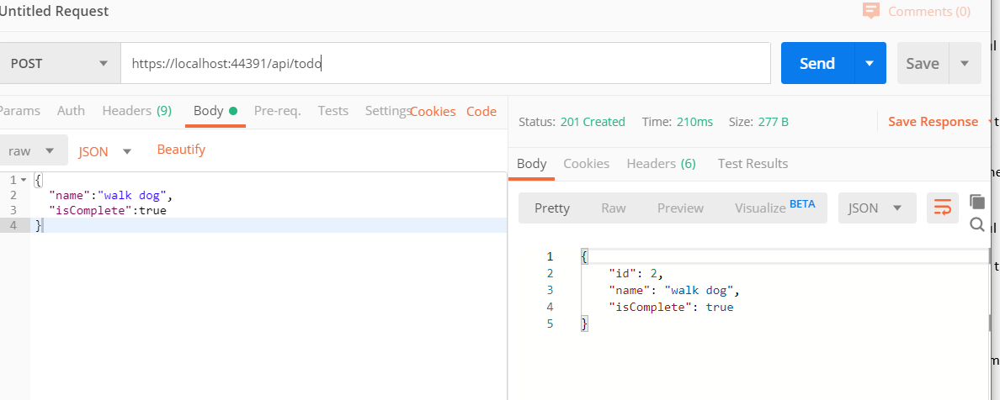

1. Using Postman, do a screen print showing a GET for the item posted from the previous exercise.

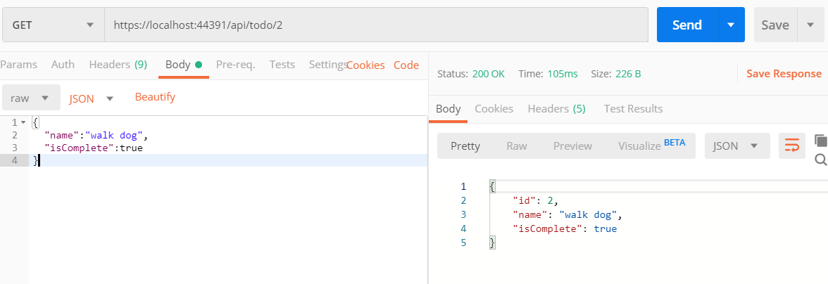

1. What status code is return for a successful PUT to the server?

201 (No Content)

1. Using Postman, do screen print showing a successful PUT of your choice.

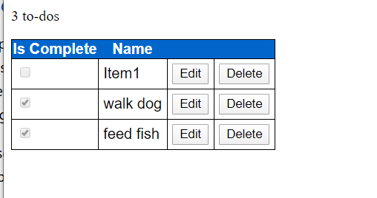

1. Using Postman, do a screen print showing a GET for the item posted from the previous exercise.

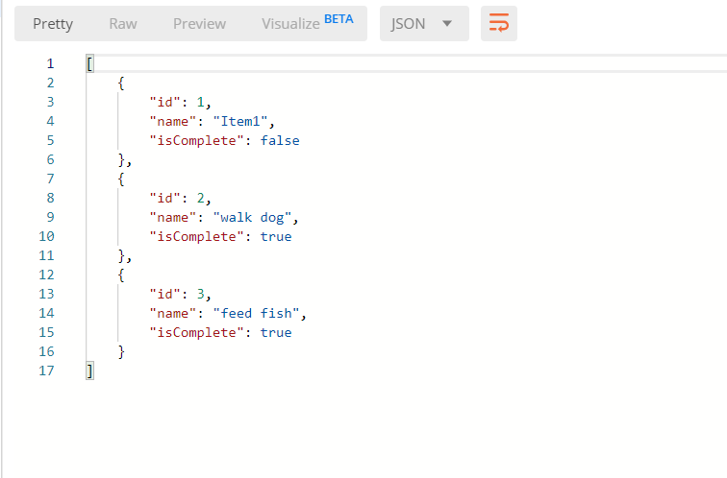

1. True or False: HTTP PUT can do partial changes.

Yes

1. Research and define what is meant by the term Idempotent in regards to RESTful services.

when making multiple identical requests has the same effect as making a single request. idempotent HTTP method is an HTTP method that can be called many times without different outcomes